Cover:

Student name: Chea Ilong

Group: 1

ID: 100022

Lab1 and 2

Advance Algorithm

Lab1-ex1: Find root of quadratic equation ax2+bx+c=0. You need to study the case delta is 0, delta is greater than 0, and delta is less than 0.

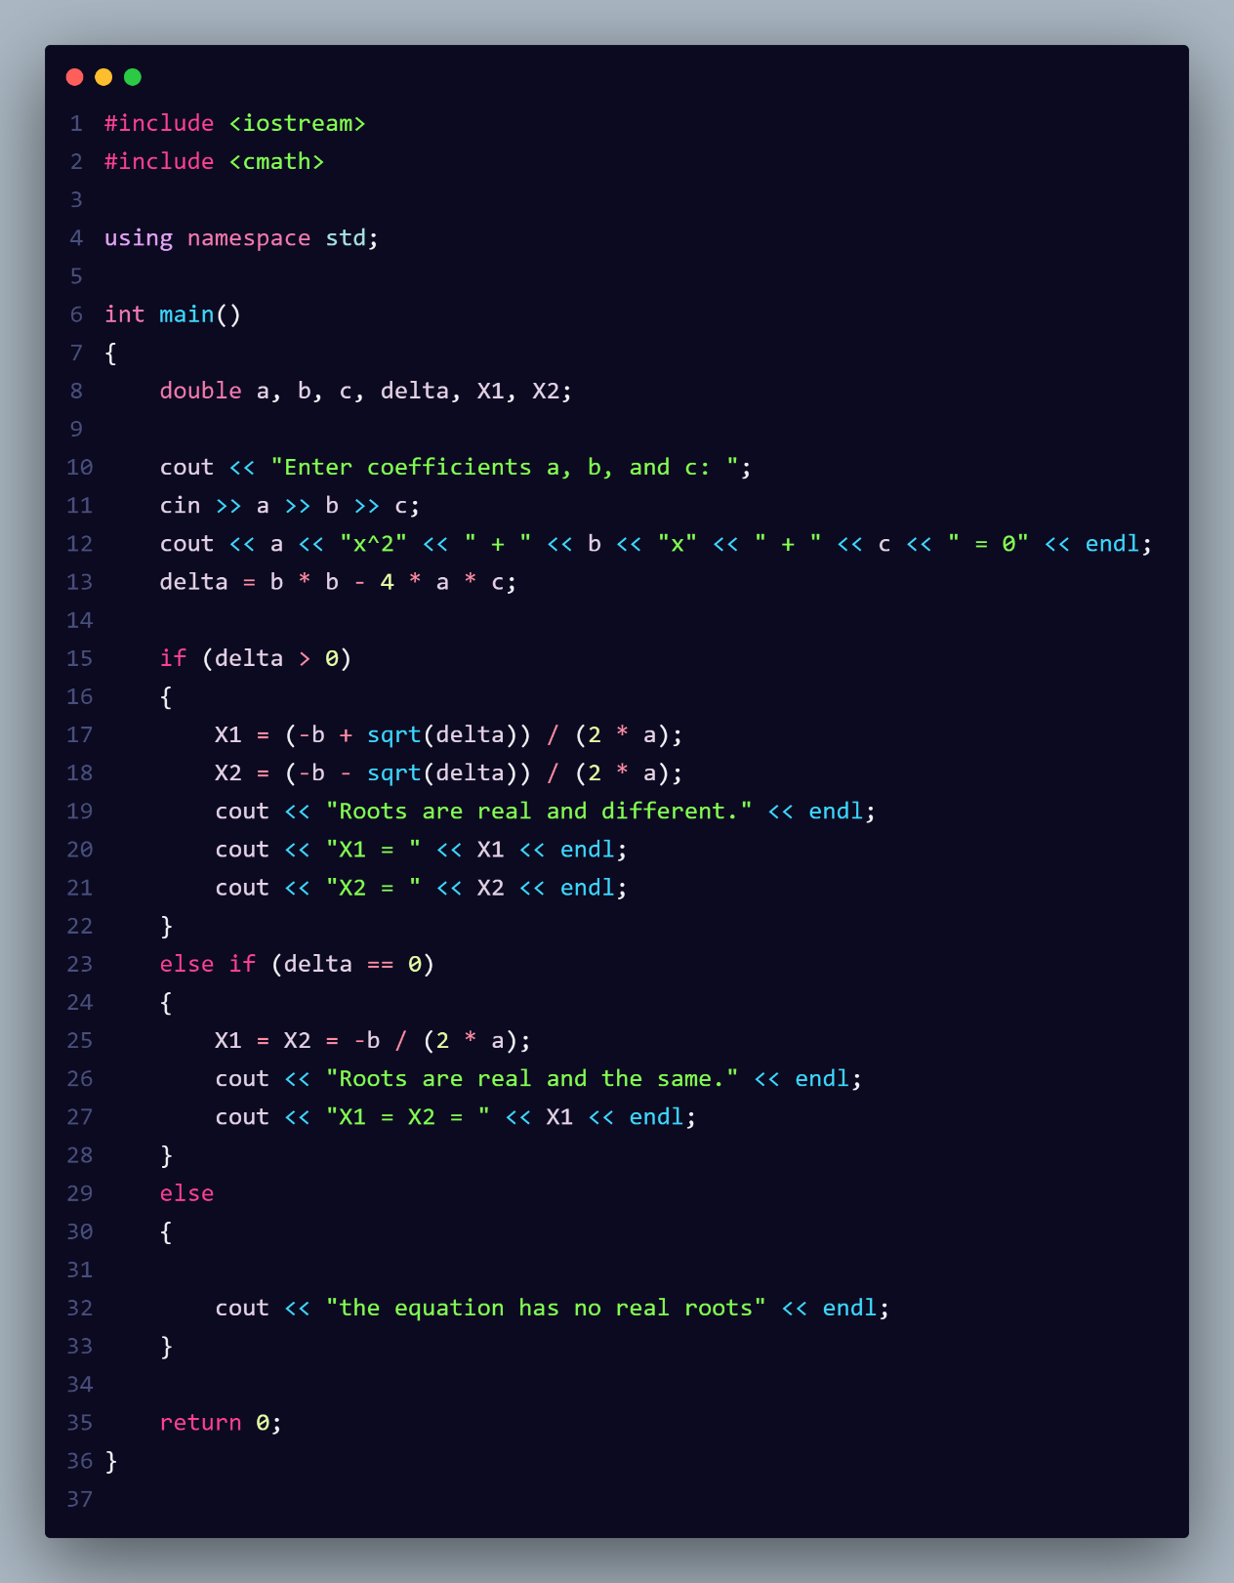

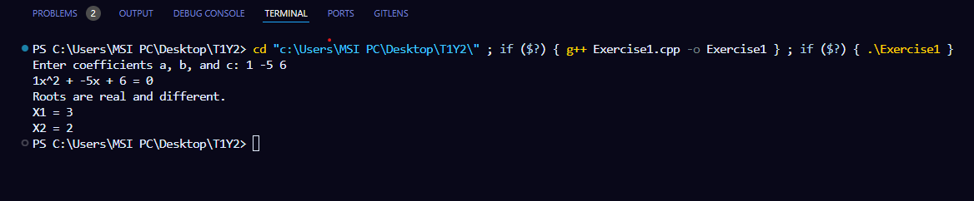

Lab1-ex2: Display numbers 1 to 1000 on the screen except the numbers 100, 200, 300, 400 and 500.

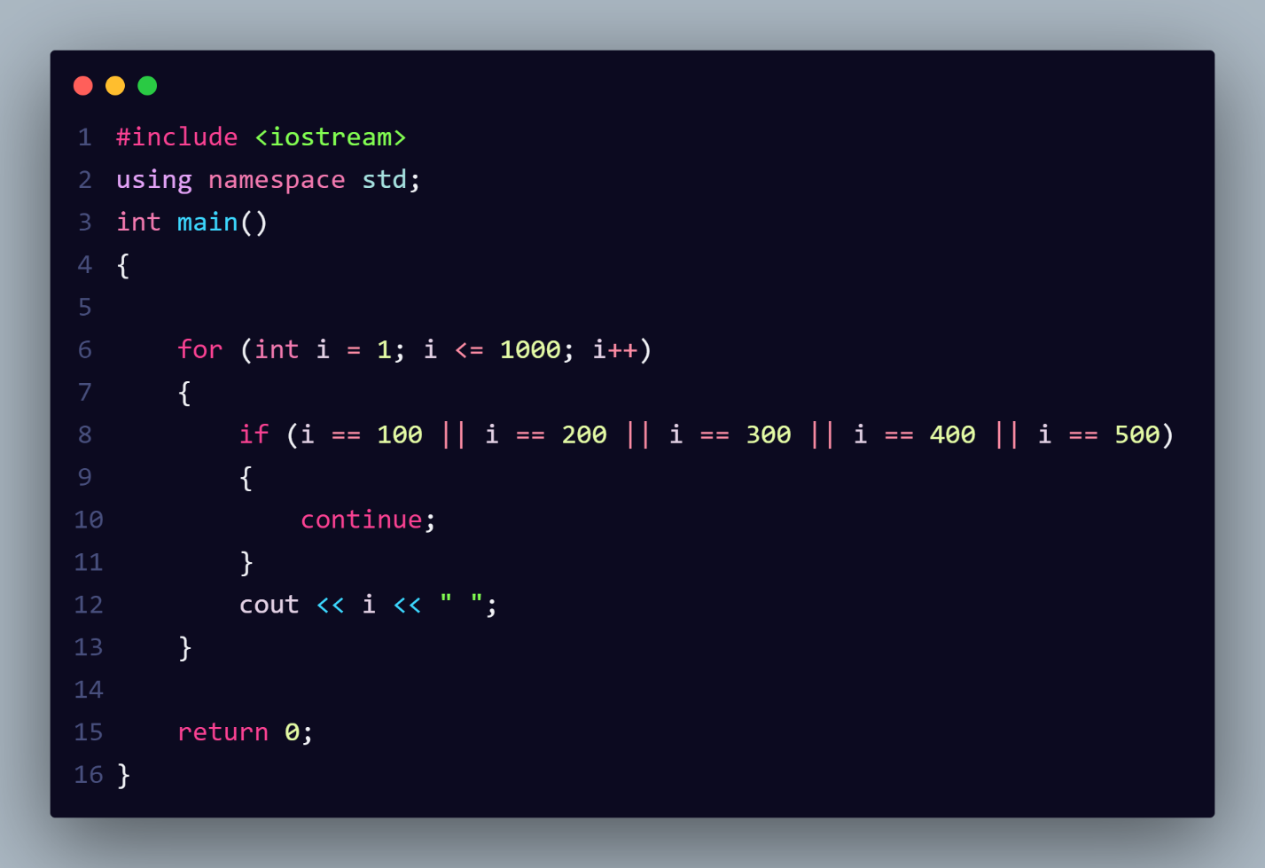

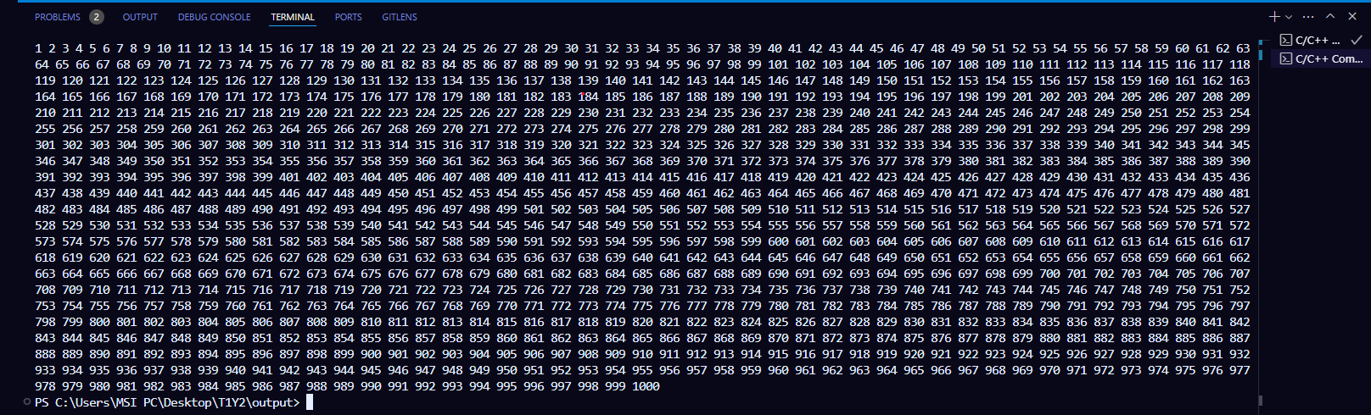

Lab1-ex3: Ask a user to input a number. Keep asking the user for more numbers until the user inputs -1. Display the total summation of all input numbers except -1.

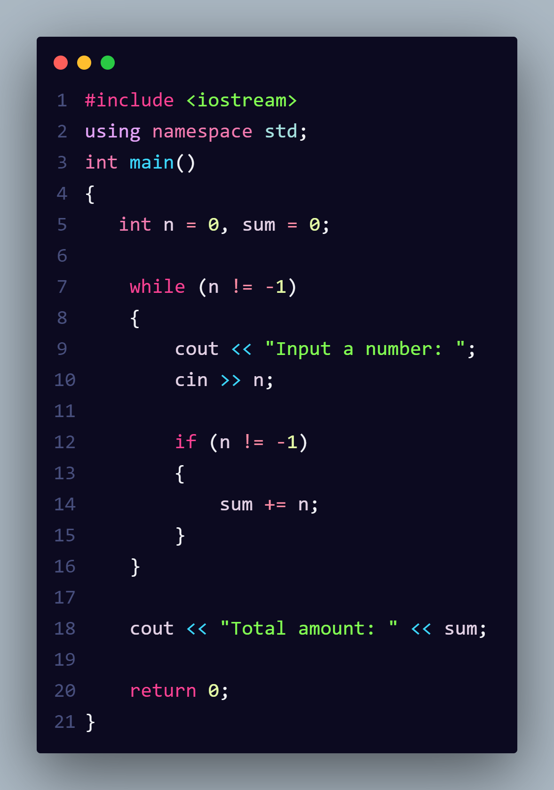

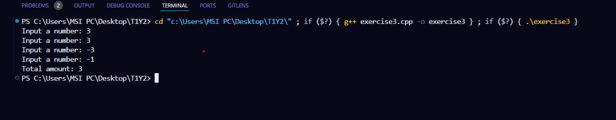

Lab1-ex4: Write a function to display and compute this suit 1/1 + 1/2 + … + 1/n , where n is the parameter of this function.

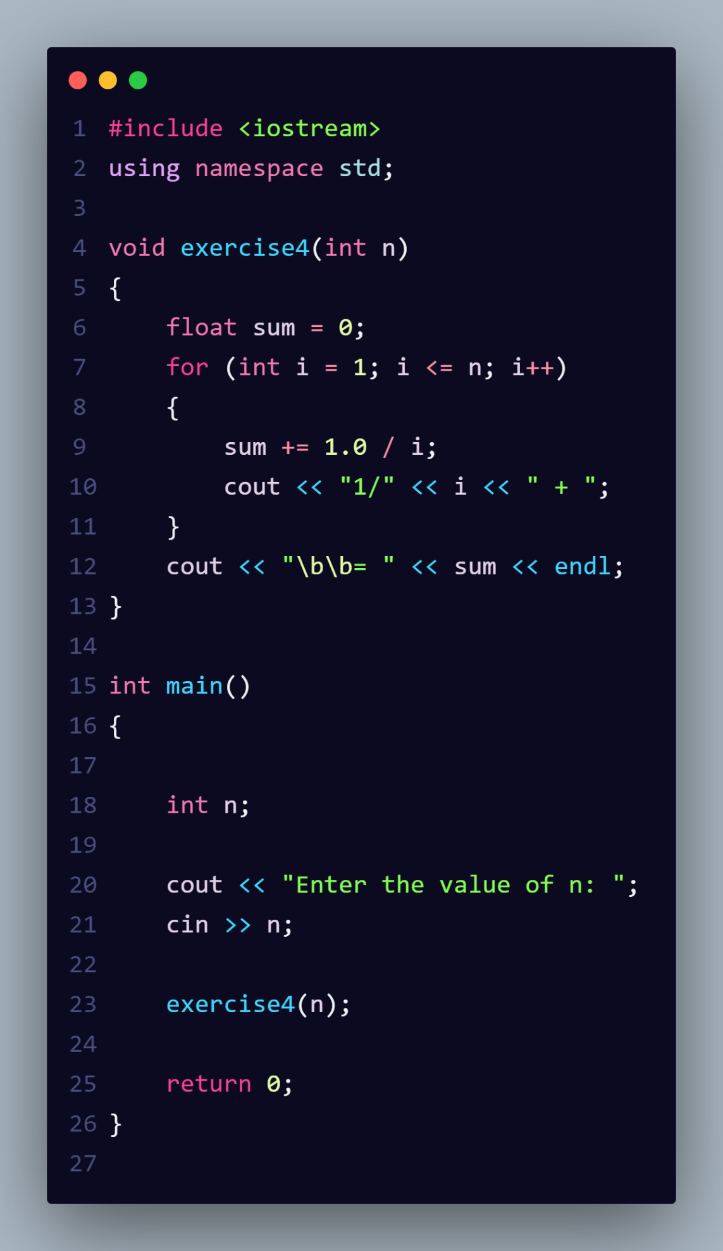

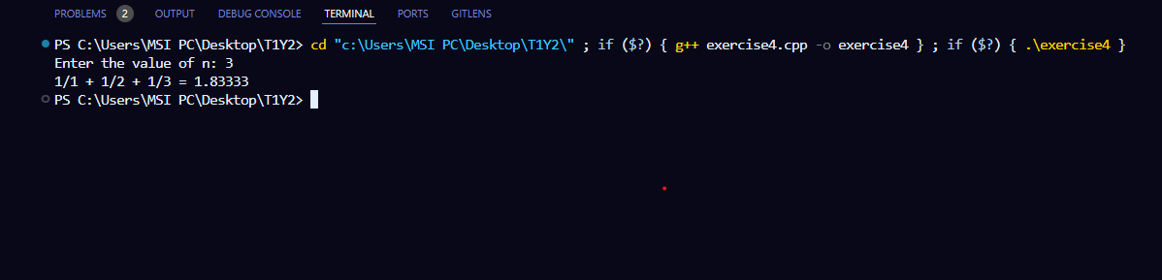

Lab1-ex5: a: a summation function to calculate the sum of the first n integer 1+2+3+…+n

B: sum digits of a number

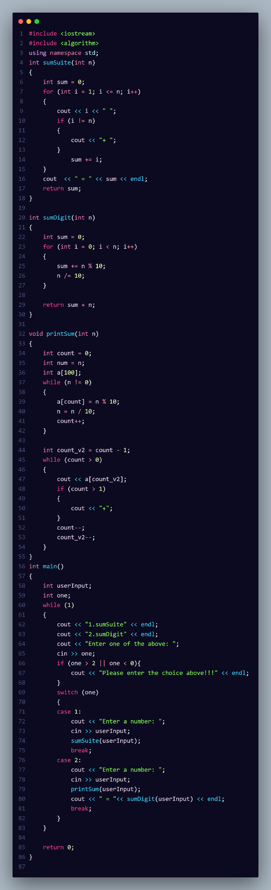

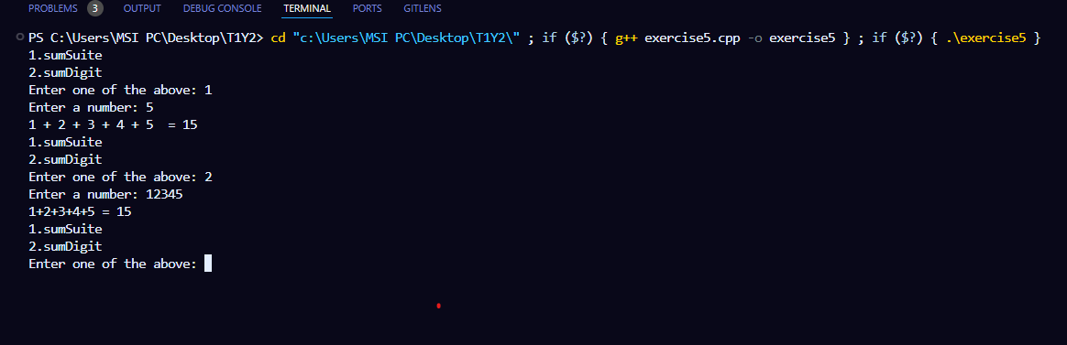

Lab1-ex6:create a struct of people. That contain information such as name, age, zodiac. And an array that can store person information up to 20 then:

1. Ask the user to input the information for 4 people and store in an array
2. Display the information for each person on screen
3. Show the information of the person with the oldest age

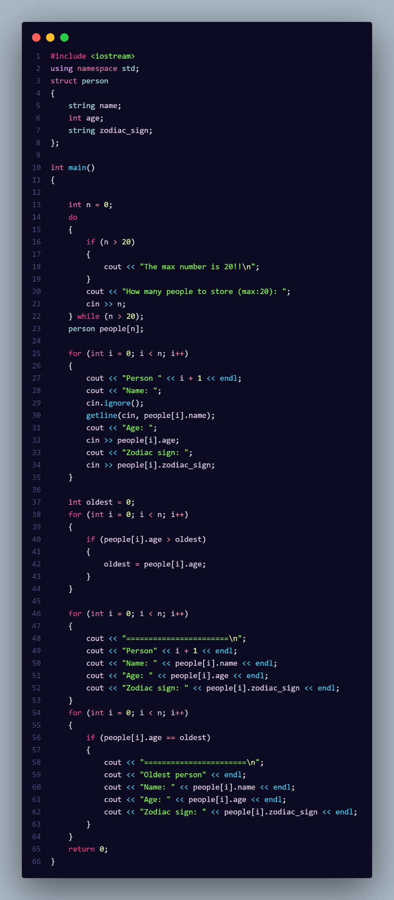

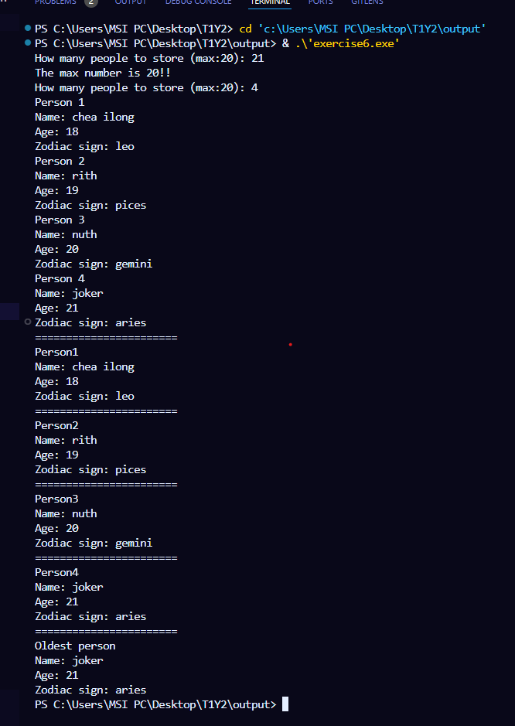

Lab1-ex7:

Get two integer x and y.

1. Display address and value of x using p1
2. Display address and value of y using p2

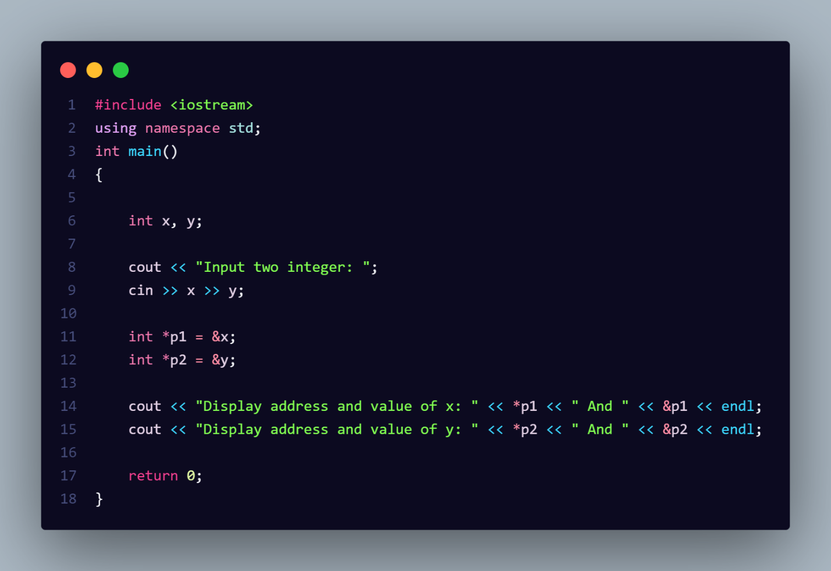

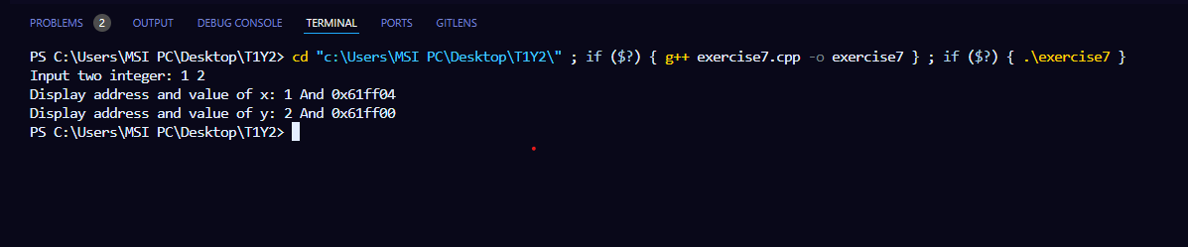

Lab1-ex8: create a function that can exchange two number.

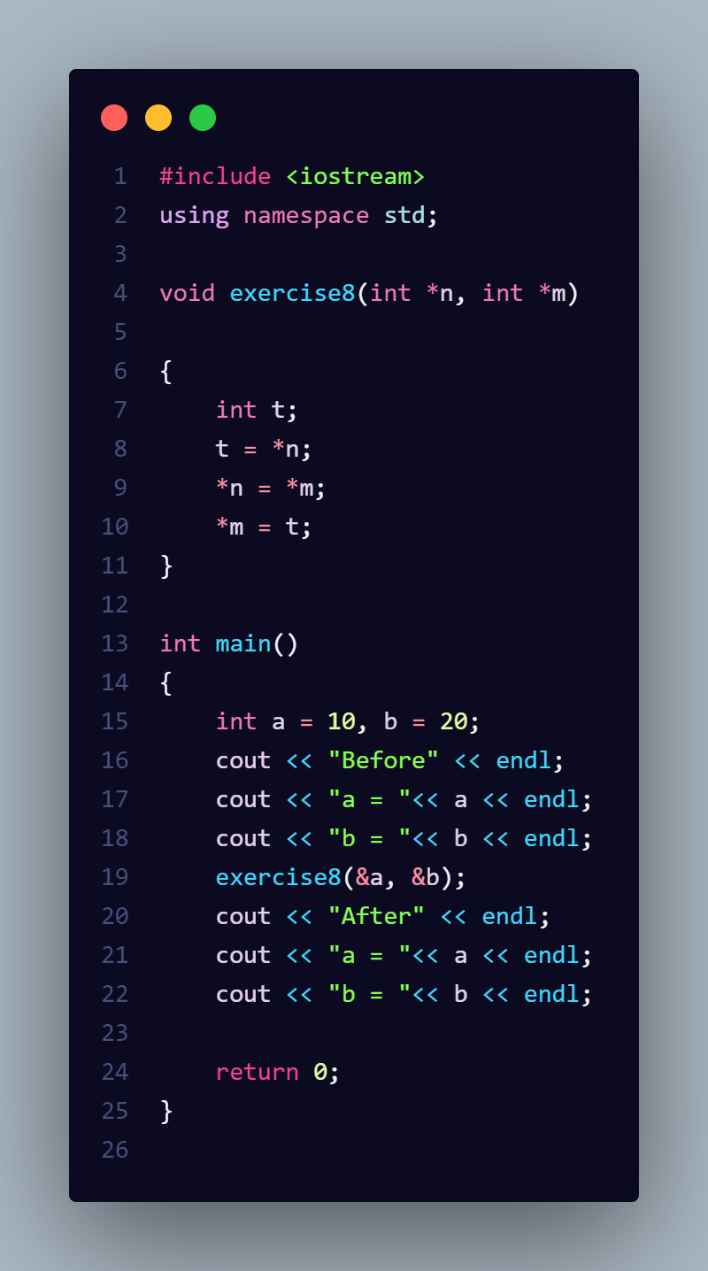

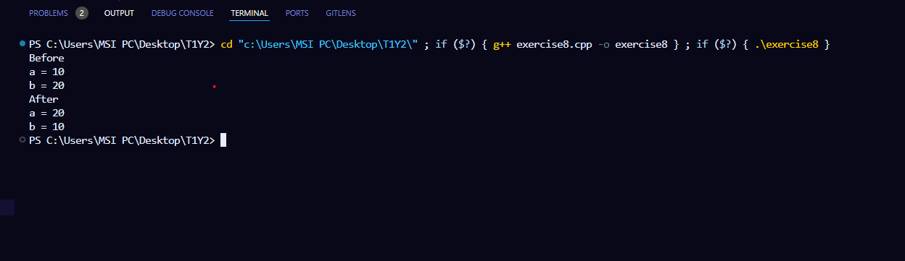

Lab2-ex1: We want to check if a given number is inside a given range. 1- Input the number and the range defined by a minimum and maximum 2- Output whether the number is "inside" or "outside" the range

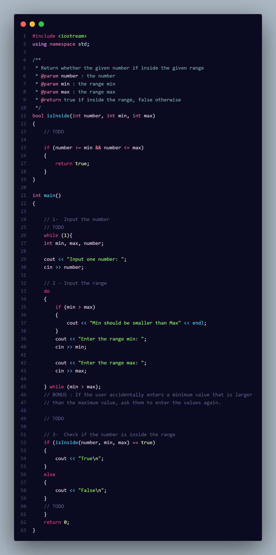

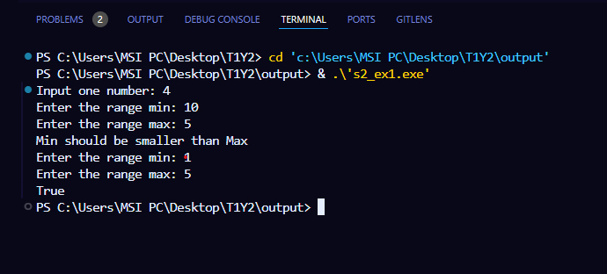

Lab2-ex2: We want to compare the ages of two people based on their dates of birth and determines which person is the youngest. 1- Input the date of birth 2- Output which person is the youngest or if they are of the same age.

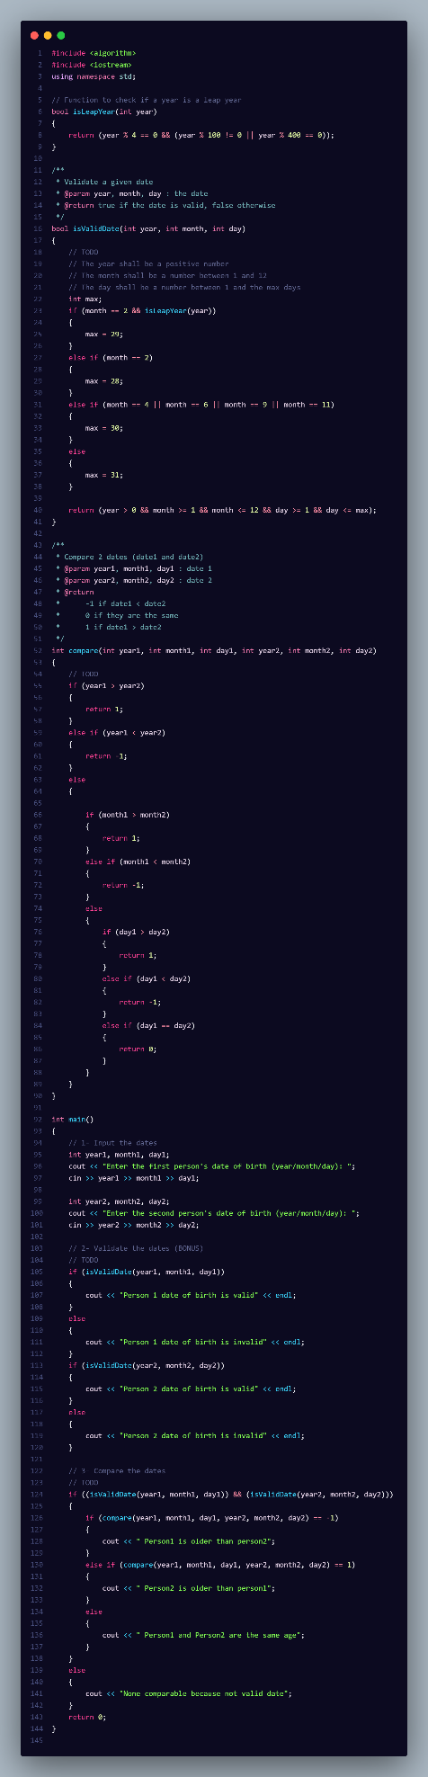

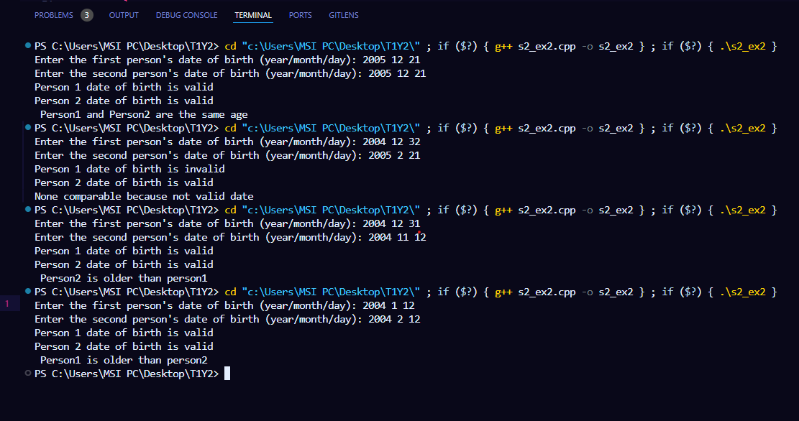

Lab2-ex3: We want, for each student of our database: • To calculate their average score • To calculate their GPA • To calculate their grade letters

